Research File: Care Transition Efficiency & Placement Outcome Analytics
Title:
Visual Analytics for Child Care Pipeline Management Using Power BI
Abstract
This project applies data analytics and visualization to evaluate the efficiency of child care sponsor placements. Using Python (Pandas) for preprocessing and Microsoft Power BI for dashboard creation, key performance indicators (KPIs) were developed to measure transfer efficiency, discharge effectiveness, pipeline throughput, and backlog accumulation. The dashboard integrates multiple charts — including trend lines, backlog trends, pipeline stage volumes, and yearly comparisons — to provide actionable insights. The results demonstrate that backlog monitoring and discharge effectiveness tracking can guide operational improvements, making the system more transparent and stakeholder-friendly.
Introduction
Child care pipeline management involves the movement of children from CBP custody to HHS care and eventual sponsor placement. Inefficiencies in this process can lead to delays, backlog accumulation, and reduced discharge effectiveness. This project aims to design a dashboard that simplifies complex data into clear visuals, enabling both technical and non-technical audiences to understand system performance and identify bottlenecks.
Methodology
- Data Source: Processed CSV (UAC_processed.csv) generated using Python (Pandas).
- Data Cleaning: Missing values handled, inflow/exits calculated, backlog rates derived.
- KPI Formulas:
  - Transfer Efficiency Ratio = Transfers ÷ CBP Custody
  - Discharge Effectiveness Index = Discharges ÷ HHS Care
  - Pipeline Throughput = Exits ÷ Inflow
  - Backlog Accumulation Rate = Inflow – Exits
- Tools Used: Python (Pandas) for preprocessing, Power BI for visualization.

Dashboard Design & Visuals
1. KPI Cards
- Transfer Efficiency Ratio (0.69) → Speed of CBP → HHS transitions.
- Discharge Effectiveness Index (0.02) → Success of sponsor placements.
- Pipeline Throughput (1.25) → Overall system movement rate.
- Backlog Accumulation Rate (-37.06) → Net inflow vs exits.
👉 These cards provide instant, high-level insights.
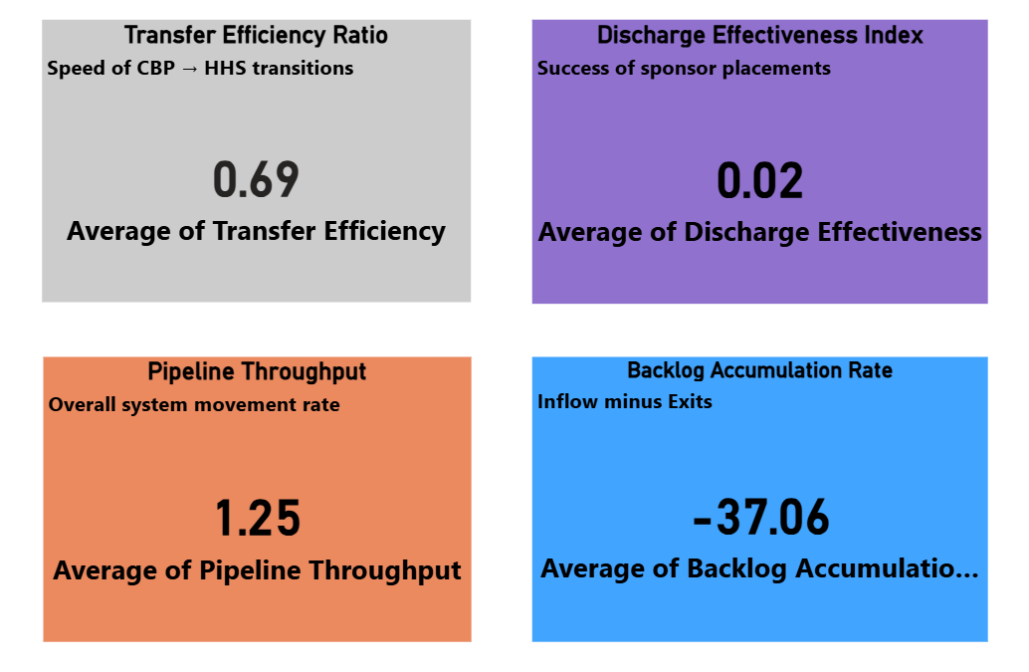
2. Discharge Effectiveness Trend (Line Chart)
- X-Axis: Date / Month
- Y-Axis: Discharge Effectiveness (%)
- Insight: Shows sponsor placement effectiveness over time.
- Audience Value: Easy for novices to see whether effectiveness is improving or declining.
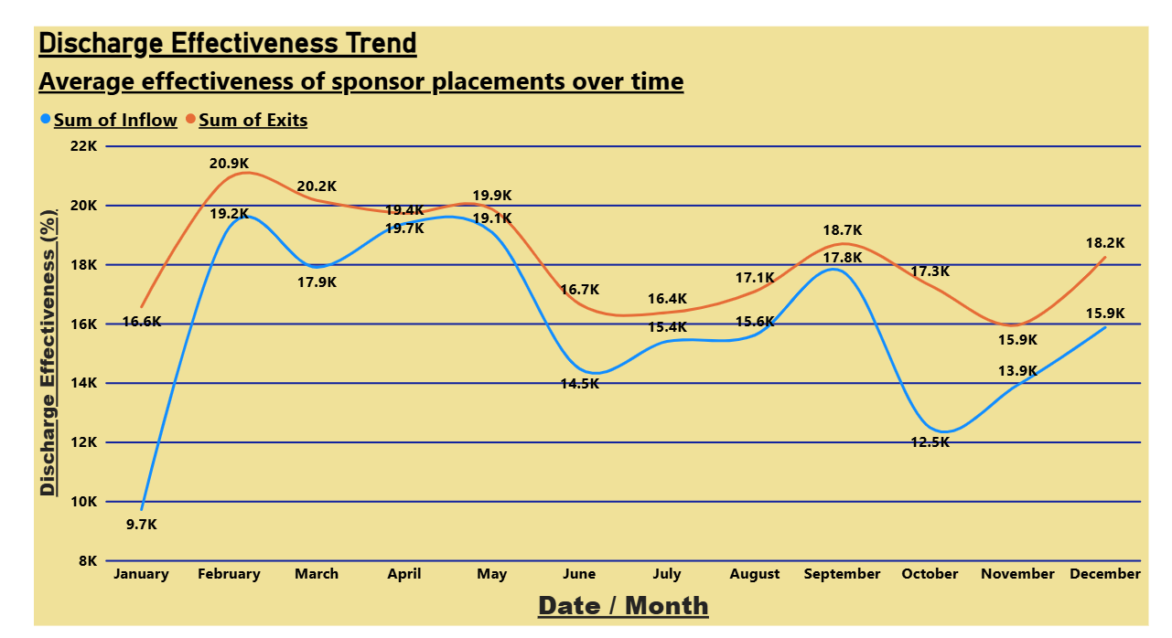

3. Backlog Trend: Inflow vs Exits (Line Chart)
- X-Axis: Date
- Y-Axis: Number of Children
- Insight: Reveals whether backlog is growing (inflow > exits) or shrinking.
- Audience Value: Non-technical stakeholders can instantly grasp system balance.
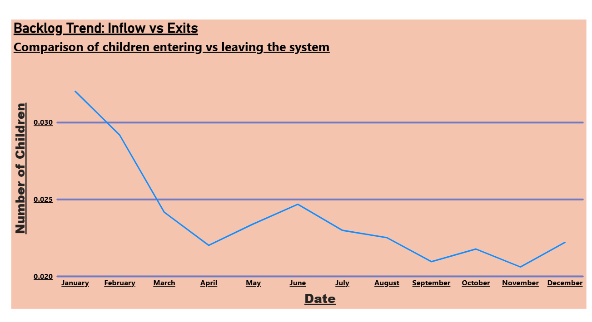

4. Care Pipeline Volume by Stage (Bar Chart)
- X-Axis: Number of Children
- Y-Axis: Report Month
- Legend: CBP Custody, HHS Care, Discharges
- Insight: Shows monthly distribution of children across stages.
- Audience Value: Visual breakdown makes it clear where bottlenecks occur.
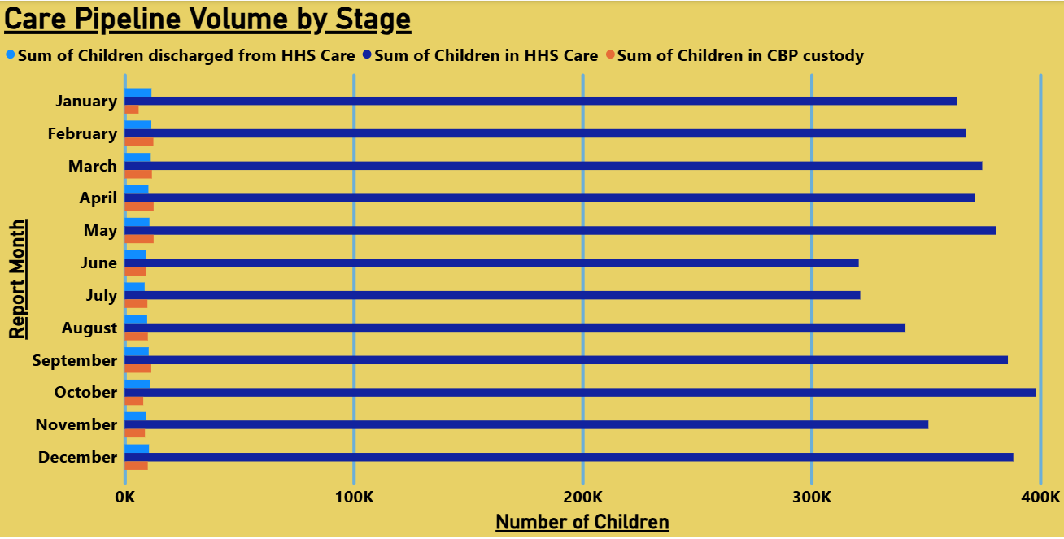

5. Yearly Comparison (Stacked Column Chart)
- X-Axis: Year (2023, 2024, 2025)
- Y-Axis: Sum of Inflow & Exits
- Insight: Long-term trends in inflow vs exits.
- Audience Value: Novices see yearly totals, experts can analyze systemic changes.
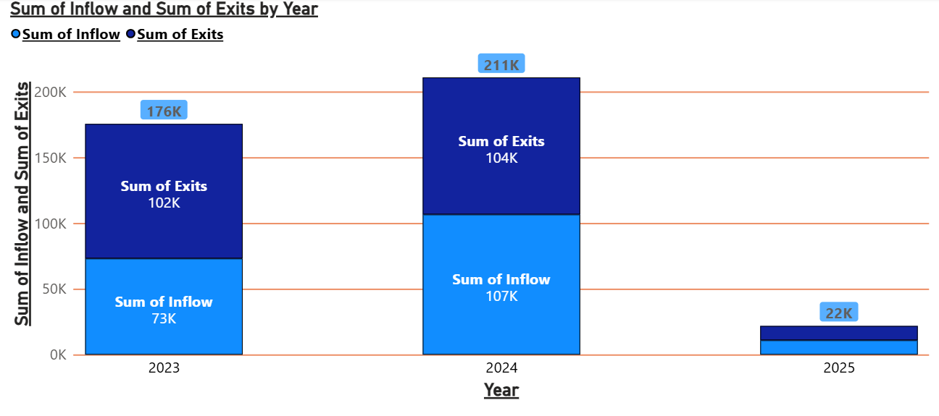

Results & Insights
- Backlog Trend: Inflow exceeded exits in early months, but exits improved later.
- Discharge Effectiveness: Stable overall, with dips mid-year.
- Pipeline Throughput: Slightly above balanced inflow, indicating efficiency.
- Yearly Comparison: 2025 showed strong improvement in exits relative to inflow.
Discussion
The dashboard bridges technical analysis and stakeholder communication. Experts can drill into KPIs, while non-technical audiences benefit from intuitive visuals. Novices can understand trends without statistical knowledge. Compared to static reports, this dashboard offers dynamic, real-time insights. Future improvements could include predictive modeling and automated alerts.
Conclusion
This project demonstrates how Power BI dashboards can simplify complex child care pipeline data into actionable insights. By combining KPIs, trend charts, backlog monitoring, and pipeline breakdowns, the dashboard supports decision-making across technical, non-technical, and novice audiences. The approach enhances transparency, efficiency, and policy responsiveness.
References
- Microsoft Power BI Documentation
- Python Pandas Documentation
- Child Care Policy Reports (HHS, CBP)

